Parts of a Seed

Name: _________________ Date: ________

There are two kinds of plants. There are plants that have one leaf in the seed, and plants with two leaves in the seed. These first leaves on a plant are called **cotyledons**.

Plants that start with one leaf are called **monocots**.

Plants that start with two leaves are called **dicots**.

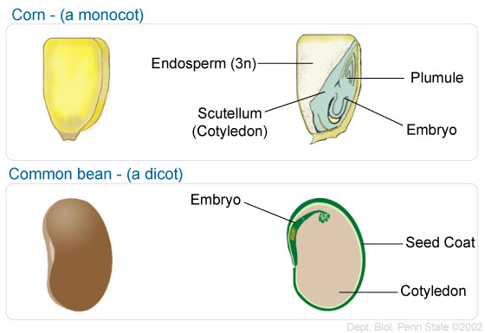

1. What Iowa crop is a monocot? ______________
2. What Iowa crop is a dicot? _________________
3. Compare and contrast the two seeds.
4. Label and color these pictures.

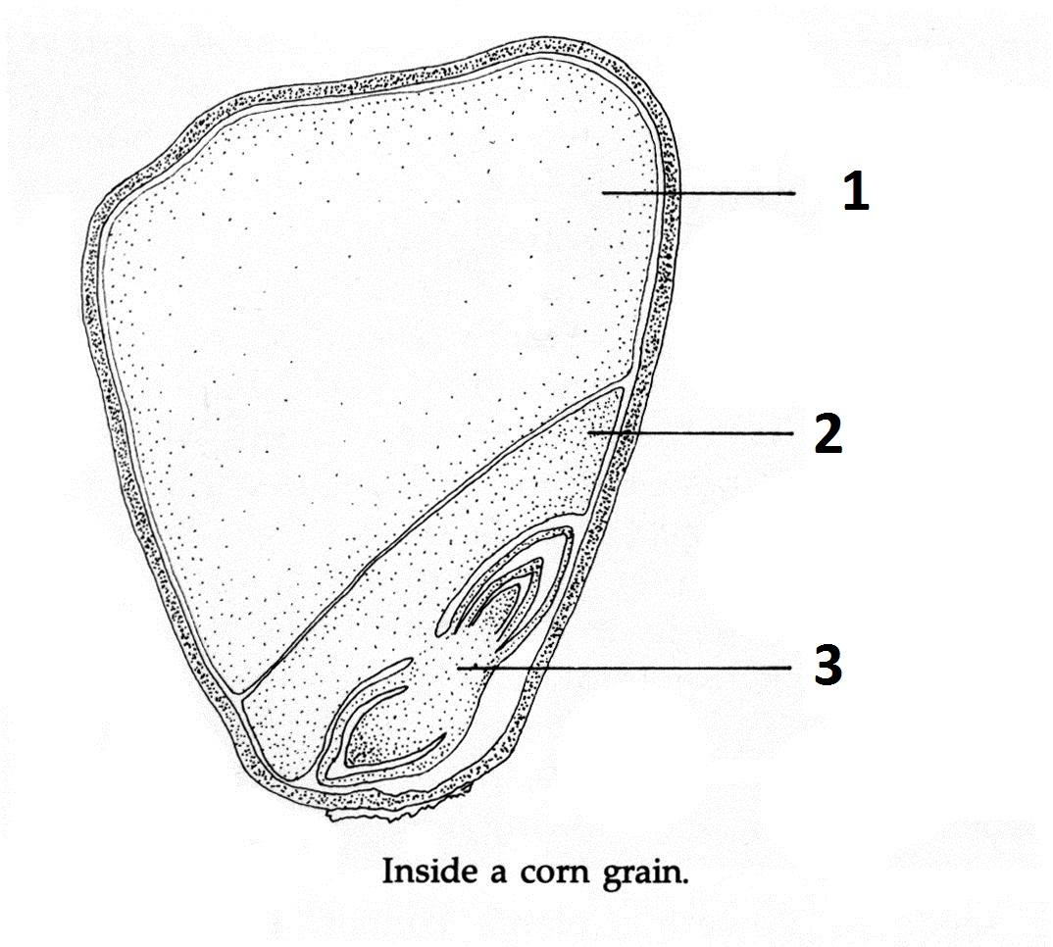

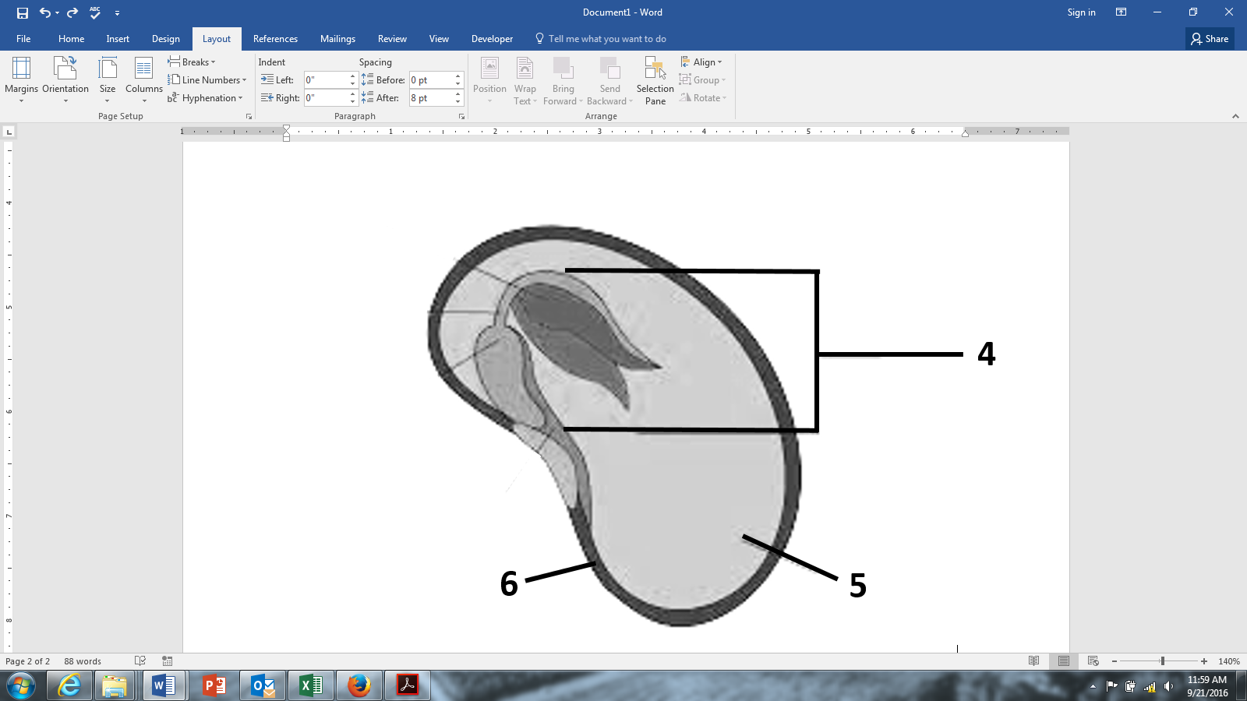

1. Look at your own seeds. What parts can you see? Draw your seeds and label what you can find.